RESOLUTION NO. 2024-225

GOVERNMENT CAMP SANITARY DISTRICT

Sole Source Procurement of Replacement Equipment for the

Aqua-Aerobic Sequencing Batch Reactors

WHEREAS the Government Camp Sanitary District ("District") operates a wastewater treatment plant ("Plant"); and

WHEREAS, the Plant has been in continuous operation for more than 23 years and requires replacement parts to address certain system failures and ensure proper continued operation; and

WHEREAS, the District's engineer of record, Curt McLeod of Curran-McLeod, Inc., has recommended replacement of the plant's Aqua-Aerobic Sequencing Batch Reactors ("Equipment"); and

WHEREAS, Oregon Revised Statutes ("ORS") 279B.075 allows a contracting agency to award a contract for goods or services without competition when the local contract review board determines in writing that the goods or services are available from only one source, and bases this determination on written findings that the efficient utilization of existing goods requires acquiring compatible goods or services; and

WHEREAS, pursuant to ORS 279B.075 and OAR 137-047-0275, on June 5, 2024, the District published a notice of intent to conduct a sole-source procurement of the Equipment from AquaAerobic Systems, Inc, of Love Park, Illinois. provided no protests are received by the end of the seven-day notice period on June 12, 2024; and

NOW, THEREFORE, BE IT RESOLVED AS FOLLOWS:

1. The Board of Directors, acting as the District's Local Contract Review Board ("LCRB"), finds that Aqua-Aerobic Systems, Inc., of Love Park, Illinois, has a long history of service to the District, uniquely provides knowledgeable expertise, and can provide compatible

Equipment that will permit efficient utilization of the existing Aqua-Aerobic SBR equipment.

1. Provided no protests are timely filed, the LCRB hereby approves the purchase of AquaAerobic Sequencing Batch Reactors from Aqua-Aerobic Systems, Inc., of Love Park, Illinois as a sole-source procurement, without competitive bidding.
2. To the extent reasonably practical, the District shall negotiate with Aqua-Aerobic Systems, Inc., to obtain the best price for the Equipment.

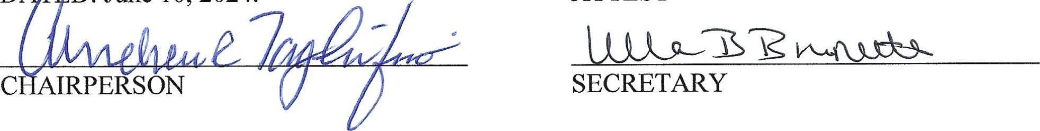

D

D:

June

10,

2024.

ATTEST

1 - RESOLUTION AUTHORIZING SOLE SOURCE PROCUREMENT Aqua-Aerobic Systems, Inc